National Cancer Research Institute
Terms of Reference
NCRI Head & Neck Working Groups - ECR Lead (x4)

Background

The National Cancer Research Institute (NCRI) is a UK-wide partnership of research funders working together to maximise the value and impact of cancer research for the benefit of patients, carers and the public.
The NCRI Groups are pivotal in these efforts and are considered the core activity of the NCRI. As a well-established part of the UK’s cancer research infrastructure, they provide a platform for researchers to collaborate, identifying and addressing areas of unmet need in cancer prevention, detection, treatment and support.
The NCRI currently manages 19 multidisciplinary Groups with wide representation from the cancer research field including clinicians, scientists, patient and carer representatives, and allied health professionals.

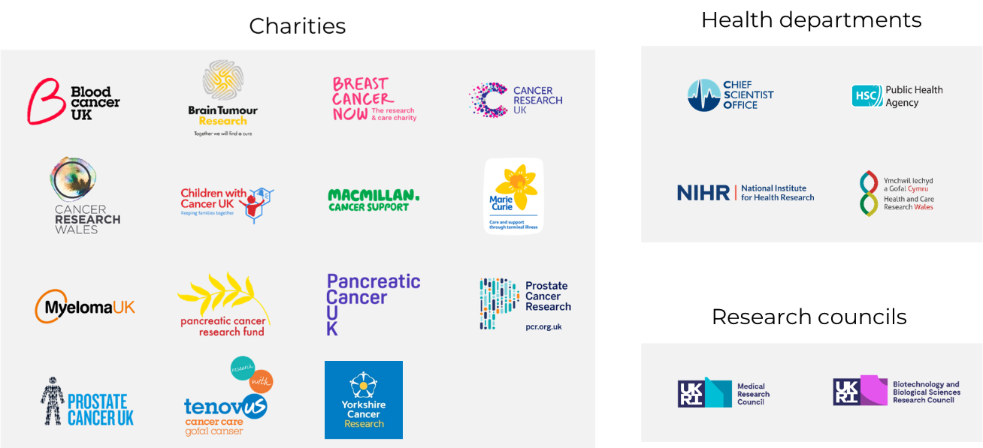
The NCRI Head & Neck Group is a multi-disciplinary community of researchers and consumers (patients, carers and others affected by cancer) focused on clinical and translational issues relating to Head & Neck cancer research. The Head & Neck Group works closely with clinical research networks, funders and national and international researchers to develop research to improve outcomes for head and neck cancer patients and identify areas of unmet need. The Head & Neck Group is currently Chaired by Martin Forster, supported by Deputy Chair Dr Shreerang Bhide.

NCRI Working Group Remit

The two main aims of the NCRI Groups and their Working Groups/Study Groups are:
To be thought leaders that set and drive the research agenda, particularly in strategic, cross-cutting areas of unmet need
To hold an overview of the cancer research portfolio to aid identification of gaps and opportunities and to advise our Partners on strategic decisions for funding and areas of focus

Every three years, NCRI Groups undergo a comprehensive process to identify and set their strategic priorities. Working Groups are currently being established to plan and implement one of the following NCRI Head & Neck Group strategic priority areas (starting with priorities 1-4):
- Working Group 1
Identify the optimal approach for collaboration between basic scientists, translational scientists, and clinicians to engage and collaborate in future head and neck cancer clinical trials.
- This priority aims to develop a workshop and produce a position paper, with HPV as a possible topic, to encourage collaboration between clinicians and scientists to strengthen clinical trials and ultimately convert discovery science into patient benefit.

- Working Group 2
Identify the gaps in salivary gland cancer research and develop strategic priorities for this area of research.
By addressing this priority, we aim to improve outcomes for patients with rarer cancers, specifically salivary gland cancer by hosting a workshop. This working group will bring together researchers from across the community to host a strategy day to identify the most important unanswered research questions in the field and develop a set of strategic priorities for future salivary gland cancer research.

- Working Group 3
Improve outcomes for patients with locally advanced hypopharyngeal cancer.
This priority aims to improve outcomes for locally advanced hypopharyngeal cancer patients by designing a study that will deliver direct patient benefit to a patient population with current unmet need.
- Working Group 4
Identify ways to improve outcomes for elderly and geriatric head and neck cancer patients and provide guidelines of how to achieve this.
Barriers resulting in a lack of diversity in clinical trials across cancer types has been raised as an issue in many of NCRI’s discussions with researchers. For this reason, this priority will be addressed collaboratively in a working group comprising experts from across NCRI Groups. This priority aims to establish the reasons behind a lack of diversity in clinical trials and provide solutions to increase participation of a diverse cohort of patients in future studies. A working group will address the common issues across the board, as well as identifying cancer-type specific barriers, and produce guidelines on the steps to take to improve the inclusion of patients from a range of backgrounds into clinical trials from their inception. More details on this working group will be decided in due course.
Working groups addressing each specific strategic priority are currently being formed. These groups will be made up of the experts needed to address each priority. To ensure you are made aware of opportunities to join the working groups, join the NCRI Head & Neck Network.

Working Groups are time limited groups that sit under the NCRI Head & Neck Group. Each Working Group will be required to produce an implementation plan which will be regularly updated and outlines the aims, outputs and activities of the Working Group.
For further information regarding each of the NCRI Head & Neck Group’s strategic priorities (1-6) click here.

Role profile
Role title | ECR Lead (x4 positions, 1 per Working Group)
Reports to | Chair of the Working Group
Commitment required | Approx. 6 working days per year on average
Location | Own institution/hospital (if opportunity arises, there may be a need to travel to London)
Salary | Voluntary role
Application deadline | 12pm Monday 8 August

Working Groups will meet roughly every 8 weeks to work towards the delivery of their set objective(s). Meeting dates will be set a year in advance in order to give members the best chance of being able to actively participate. At the end of each Working Group lifecycle, the main group will revisit their list of agreed strategic priorities and a new Working Group will be formed to address the next objective.
Responsibilities of ECR Lead
The ECR Lead will play a key role in supporting the Working Group Chair/Deputy Chair from the outset to develop and maintain the implementation plan, which will outline the aims, outputs and activities of the Working Group.

In addition, ECR Leads will be expected to:
- Support the NCRI Group Coordinator by checking the scientific validity of meeting summary notes and action points
- Act as a key contact/spokesperson for all ECRs involved with the Working Group i.e., responsible for raising updates/queries on their behalf, as required

As well as attending the meetings of your assigned Working Group, ECR Leads will also have the opportunity to attend Head & Neck Group meetings on a rotational basis.
ECR members
Additional ECR members will also be recruited (alongside the ECR Lead) to contribute towards the delivery of the Working Groups set objective(s).

The number of ECRs recruited to a Working Group will be dependent upon the requirements of the Working Groups set objective(s), and the capacity of the group to support the ECR(s)with a specific role and a Scientific Mentor for the duration of their tenure.

All opportunities to apply for ECR membership of Working Groups will be circulated with the ECR Forum.
Membership term
Working Groups are time limited, therefore the ECR Lead tenure will be for the duration required to fulfil the strategic priority, as defined by the implementation plan.
Remuneration
This is a voluntary position and is therefore not remunerated. However, should Working Group members be required to attend face to face meetings (where deemed essential), all reasonable out of pocket expenses I.e., travel (as advised by the NCRI Executive) will be reimbursed in line with the NCRI Expenses Policy.
Equal opportunities
NCRI is committed to creating and encouraging a culture that promotes respect for each other and values individual differences. In addition, it is important that we can create a safe environment for all NCRI Group/Working Group members in which they can engage with one another, share views and form meaningful collaborations. In order to achieve this, we provide equal opportunities to members of any colour, nationality, ethnic origin, marital status, religion or belief, gender, disability, sexual orientation, age or employment status.
We will not condone, tolerate or ignore any form of discrimination or unacceptable behaviour in our recruitment practices or in the conduct of the NCRI Groups/Working Groups and its members.
If you have any queries or concerns of this nature, please contact the NCRI Head & Neck Group Manager Carolyn Chan. A copy of NCRI’s Equality, Diversity and Inclusion (EDI) Policy is available via the following link.
Meeting conduct
All members have an accountability to the NCRI Group/Working Group recognising the importance of attending meetings, and those relating to any other NCRI Group of which they are a member. Where attendance at a meeting is not possible, apologies should be sent in advance to the meeting organiser/coordinator.
NCRI Groups/Working Groups (and anyone involved in/associated with NCRI Group/Working Group activities) are expected to be respectful of different viewpoints and experiences, and to behave professionally at all times. To ensure a safe environment for all, members must not share meeting invites or joining details with non-members.
How to apply
If you are interested in the role of ECR Lead (NCRI Head & Neck Working Group) please complete the online application form by 12pm Monday 8 August. In addition to pre-screening questions, a copy of your CV will be required in support of your application.

If you have any queries regarding the role, please contact Hannah Taylor (Forum Coordinator) via hannah.taylor@ncri.org.uk. For further information on NCRI Groups including meeting frequency and membership composition, please see the NCRI Groups handbook.

